Howto do umrah
UmraTo simply circuit the Ka’ba and perform the seven circuits between Safa and Marwah is called Umra. There is no fixed time for Umra and it can be performed at any time during the year except between the 9th and the 13th of Dul-Hajj (these days are only reserved for the full pilgrimage or Hajj). Entering into the state of Ihram and removal of Ihram is carried out in the same manner as for the full pilgrimage
Departure from Home:
A Muslim must be mindful of his/her duties towards family and fellow human beings. A Muslim who intends to perform Hajj must make sure, before departing for Hajj that his family is provided for during the period he is away for the Hajj. He should pay up his debt and seek forgiveness from fellow human being whom he might have caused harm in the past. He should be diligent in observing Salat (five daily prayers) and Sawm (fasting) in the month of Ramadhan as well as carrying out other religious obligations. He must shun all arrogance and exhibit a character of modesty and humbleness. He must not use unlawfully acquired money or unlawful means to perform Hajj. He should seek sincere repentance from Allah of all his past sins. In short, one should depart for Hajj just like one would wish to depart from this world.
One should spend some money in charity as well. A woman is not allowed to perform Hajj alone and must be accompanied by an adult Muslim Mahram (father, husband, son or brother etc.)
One should say two RakatNafl (supererogatory) prayers before leaving home for Umrah.( if you Already in IHRAM)
One should say two RakatNafl (supererogatory) prayers for Ihram Also.
Preparing for Ihram
•To perform Ghusl (shower) is Sunnah
•Trim your finger and toe nails if needed
•Shave under your arms if needed
•Shave your pubic hair if needed
•Trim the moustache (leave the beard as it is)
•Apply perfume to your head and beard (men only), and not to the garments.
How to Enter into a State of Ihram.
•Men wear the lower part by wrapping it around their waist
•The top part is thrown over, covering both shoulders; the right shoulder is only open during Tawaf
•It is acceptable to wear a money belt to assist in “keeping up” the lower part
•A safety pin is also very useful to keep the top part from falling off or constantly opening up
•There are no special clothing requirements for women in Ihram; other than, not covering the face and hands while in Ihram
•It is acceptable to adopt the Ihram clothes prior to reaching the Meqaat
•The intention to begin Hajj and Umrah is to be made aloud by saying:
What you can do in a state of Ihram
•Wearing a wristwatch, eyeglasses, money belt, rings, sunglasses, hearing or speech aid, etc
•bath or shower with unscented soap and to wash and gently scratch one's head and body, even if hair may fall out
•Changing one’s Ihraam garments, removing the Ihraam clothes does not nullify the state of Ihraam
•Having a shelter over one’s head, whether in a car, under an umbrella, or in a tent or building
•Covering feet (but not their head) while sleeping, with their Ihraam or a blanket
Only after uttering the niyah does one become a muhrim and thus the following prohibitions apply.
Men Must Not:
•Wear clothes that are tailored to fit parts of the human body, e.g. trousers, jackets, etc
•Wear any sandal or shoe that covers the ankle
•Wear any underwear or headgear
Women Must Not:
•Though women can wear normal clothes, they must NOT wear gloves or a face cover that has openings for their eyes, although they can fully cover their faces and hands in the presence of men who are not their mahram
Both Men and Women Must Not:
•Apply perfume, wear perfumed clothes, nor use any perfumed substances
•Trim his/her nails
•Cut his/her hair
•Neither marry, give anyone else in marriage, nor propose marriage
•Perform any act likely to arouse sexual passion or indulge in any intimate marital relations
•Hunt or participate in hunting
•Commit an act of disobedience to Allah, such as smoking
•Get involved in idle talk or disputes, i.e. fights, arguments and quarrels.
General Etiquette while in Ihram
•Avoid walking around with only the bottom part of your Ihraam.or
•Men should recite the Talbiyah loudly, a woman raises her voice only to the extent of being heard by the person next to her; the Talbiyah is made by saying:
•Keep your right shoulder covered (except during Tawaf)
•Avoid throwing the ‘lose’ end of your Ihraam over your shoulder, as you may ‘hit’ the person behind you in the face
•Keep your Ihraam clean and do not use it as a cloth to wipe your hands
•Take extra care as to how you sit, especially on stairs, to avoid exposing yourself. As it is unusual for you to be without underwear, you can easily expose your private parts. This is very common while sitting on the stairsinside the mosque
One should say two RakatNafl (supererogatory) prayers before leaving home for Hajj.
Talbiyah
After putting on the Ihram, men and women offer two Raka’ts of Nafl (supererogatory) prayers followed by recitation of their “intention” and saying the following words:“LabbaikAllahummaLabbaik; La Shareeka-lakaLabbaik; Innalhamda wan-na’mata-lakawal-mulkaLashreeka-laka

Translation:لبيك اللهم لبيك . لبيك لا شريك لك لبيك . إن الحمد والنعمة لك والملك . لا شريك لك

“Here I am, O Allah! Here I am in Thy August presence; there is no associate with Thee, here am I; surely all praise is Thine and all favors are Thine and the kingdom is Thine, there is no associate with Thee.”
These words are recited in Arabic and called “Talbiyah”. These words are an essential part of the state of Ihram and Ihram will not complete without reciting these words. After saying Talbiyah pilgrim is ready to fulfill his obligation of Hajj and is required to fulfill all the conditions laid down for Hajj. While one is in the state of Ihram it is strictly forbidden to engage in foul talk, sexual conduct, arguments, or enter into a war. Allah says in the Holy Quran: “ …so whoever determines to perform the Pilgrimage in these months, should remember that there is to be no foul talk, nor any transgression, nor any quarreling during Pilgrimage. …” (2:198)
Entering Masjid-el-Haram
After reaching Mecca, one should head straight to Ka’aba that is situated in bounds of Masjid-el-Haram and perform Tawaaf. It is said that when one has his/her first glance at Ka’aba, whatever prayers one makes is granted.
Istlam
(Kissing the Hajr-e-Aswad)
The act of kissing the Hajr-e-Aswad is called Istlam. While kissing the Hajr-e-Aswad, ones hands should be on the wall of the Ka’ba in the same position as when one performs a Sajdah (prostration) during a prayer. If it is not possible to kiss the Hajr-e-Aswad, it is permissible just touch it with a hand and if that is not possible the just point to the Hajr-e-Aswad and blow a kiss to it.
Tawaaf (Circling of ka’ba)
After performing Istlam (kissing the Hajr-e-Aswad) as described above, a pilgrim should perform Tawaaf of Ka’ba. Tawaaf is performed by going around Ka’ba seven times keeping the Ka’ba on left hand side (counter clock-wise). Istlam should be performed during each circle. It is also permitted to perform Istlam of Rukun-e-Yemeni (Pillar of Yemen). The seventh circle ends at the Hajr-e-Aswad.
Nawafal at Muqam-e-Ibrahim
► ► ► 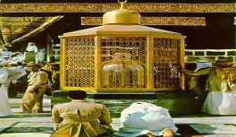
After completing the Tawaaf, the pilgrim should move to the Muqam-e-Ibrahim (Place of Ibrahim. At this place one should offer two Rakats of prayer while facing Ka’ba.
Sa’ee (Running between Safa’ and Marwah)
► ► ► 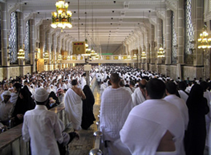
Allah the Exalted has said the Holy Quran:
“Surely, Al-Safa and Al-Marwah are among the Signs of Allah. It is, therefore, no sin for him who is on pilgrimage to the House, or performs Umra, to go round the two. And whoso does good beyond what is obligatory, surely then, Allah is Appreciating, All-Knowing.” (2:159)
After praying two Rakats of prayer at Muqam-e-Ibrahim, the pilgrim then moves to “Safa”. At this place, he should face towards Ka’ba and recite Durood, Takbir and Talbiyah. The he should walk briskly towards Marwah and recite the same at Marwah. This counts as one circuit. Now one should move to Safa’ and repeat the prayers. One should complete seven circuits between Safa’ and Marwah. These circuits are called Sa’ee.
Shaving or clipping of hair.
► ► ► 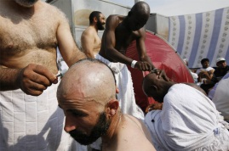
After Sa’ey, men should get their heads completely shaved or get their hair clipped to the length of the upper third of their finger or a little more. Both shaving and clipping are permissible for men, though shaving is preferable. Women are, however, allowed to have a lock of their hair clipped. They are forbidden to shave their heads.
Umrah is complete. After cutting the hair, umrah is complete. The restrictions of Ihram are finished. Now wear your everyday clothes and lead a normal life. Be thankful to Allah that He provided the opportunity for performing Umrah and lead rest of your life according to the commands of your Creator.After performing the circuits between Safa’ and Marwah, one is free to move about and go to a resting place.
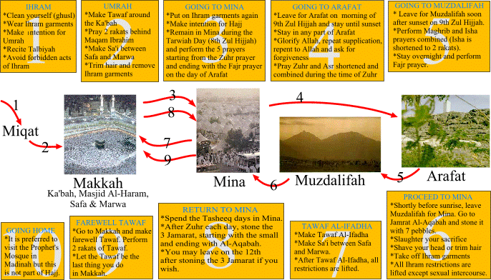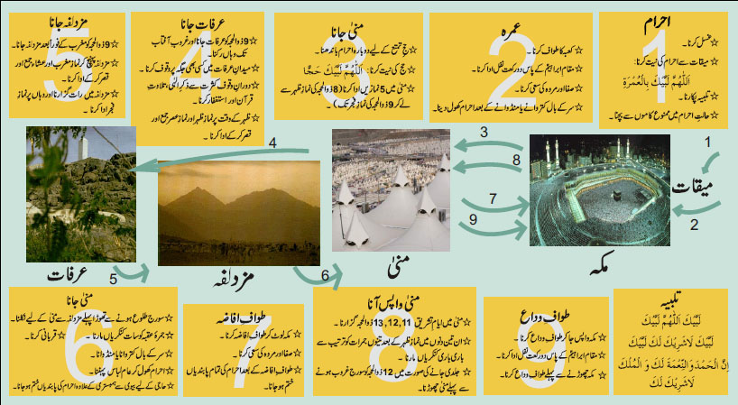
You can do Umrah as much as you want when you stay in Makkah.
To do umrah again please go to Masjid Aishah (Masjid Umrah) and have aIhraam.
Pray twoRakatNaflMasajid when you are in (Masjid Aishah ,Masjid Umrah).
Please pray twoRakatNafl (supererogatory) prayers for Umrah.( if you Already in IHRAM).
Now you go back to Masjid-el-Haram and start umrah

H A JJ PACKAGE DETAILS 2015
Arrival At Jeddah ( Hajj Terminal )

▼▼▼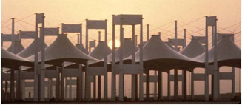 ◄◄◄

IMPORTANT
Please Read It Carefully
STEP 1 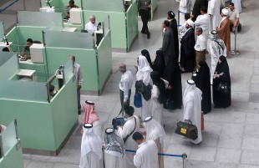
At Jeddah airport Please go to immigration. After immigration you go through the customs for luggage clearance. Processing time takes at least 5-6 hours.↓▼
STEP 2 ►►
At this time please check your luggage and get trolleys. If you would rather keep your luggage with you then proceed to Step 3. Or if you want to put your luggage on the large trolley then either designates one person from your group to follow the trolley or you may follow the trolley to make sure where your luggage is being held. Then alternate between your groups to make sure that everyone gets to complete step 3.
STEP 3▼▼
Outside of the customs area, please go Unified Agents Office And give him your passport will detach Mau'alim fee check SAR 1029.(which we have attached at the last page of your passport). And he will attach stickers for transportations in your passport.
THIS IS A PERFECT TIME- to get your Dollar $ changed to Riyals. These guys love the NEW DOLLAR BILLS take them with you for better exchange rate. Old will be good but for the regular exchange rating.
STEP 4▼ 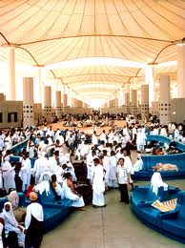► ►
After you Give your passport with bank check to Unified Agents Office in Jeddah Airport please check in office many time for you bus to Makkah. It takes about 6-7 hour to wait at Jeddah airport for bus to go Makkah.
STEP 5 ►► ► 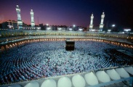
When you arrival At Makkah At mualam (mutawaf) Office we will pick you from office to building at makkah. After the rest at Building please go with group for Umrah In haram Sharif.
21SEP. ( 8-Zilhajj)
Transfer From makkahbulding to Mina.
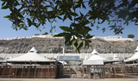→ → → →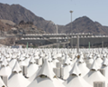
On 8th day of Dul-Hajj the inshallah we reach at Mina early in the morning after performing Tawaaf-Qudoom. A pilgrim offers Duhr, Asr, Maghrib and Isha’ prayers at Mina and camp there for the night.
22SEP. (9-Zilhajj)
▼▼▼Arriving at Arafat▼ ▼ ▼
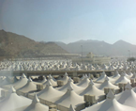►►►►►►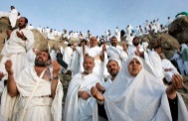
On 9th day of Dul-Hajj, after offering Fajr prayer, a pilgrim should move to Arafat. Stay at Arafat is called Waqoof and is the most important part of Hajj. Without this, Hajj cannot be considered complete. If someone misses Waqoof, he should perform Hajj the following year. One listens to the sermon at the plane of Arafat and offers combined Zuhr and Asr prayers. One should stay at Arafat till sunset (Maghrib).
Arriving at Muzdalifah ▼ ▼ ▼
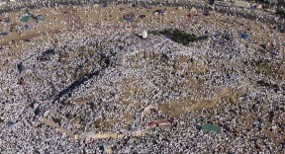
One leaves Arafat after sunset and reaches Muzdalifah in the evening of 9th Dul-Hajj. Combined Maghrib and Isha’ prayers are offered at Muzdalifah. The pilgrims spend the night at Muzdalifah
After Fajar pray In Muzdalfa travel Back to Mina tent. Departure from MuzdalifahOn the
23SEP. (10th day of Dul-Hajj)
The pilgrims offer their Fajr prayer as early in the morning as possible. After the Fajr prayer a pilgrim leaves Muzdalifah and arrives at Mina. When you are in Muzdalifah every one should pick up (49) small stones. As soon as he reaches Mina, he should cast seven stones at Jumrah-tul-Aqba. (Throwing 07 Stones on BIG Jamrat)
▼ ▼ ▼
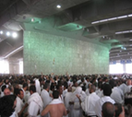
This act of throwing stones is called Rami. With the throwing of the first stone the requirement to repeatedly recite Talbiyah is lifted. If the pilgrim intends to sacrifice an animal then he should do that after casting stones ad Jumrah-tul-Aqba. After offering the sacrifices a male pilgrim should have his head shaven and female pilgrims are required to cut a small part of her hair. Femle pilgrims are not permitted to have their heads shaven. After the hair cut one can remove the Ihram and may now wear regular cloths.
Return to Mecca after sacrifice and haircut. Perform Taawaf-e-Afaza▼ ▼ ▼
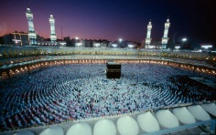
After the removal of Ihram the pilgrim is required to return to Mecca to perform another circuit of the Ka’ba. This particular circuit is called Tawaaf-e-Afaza(additional circuit) and is an essential part of the pilgrimage. After this circuit a pilgrim is permitted to return to normal life and all those lawful things that were forbidden are now allowed again.Go back and Stay overnight in Mina
24SEP. (11 Day Of Zilhajj)
Throwing 07 Stones on Each Jamrat ** BIG** SMALL** MEDIUM ** as Group or by self
► ►► 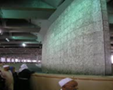►► ►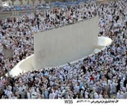
Go back and Stay overnight in Mina.
25SEP. (12 Day of Zilhajj)
Throwing 07 Stones on Each Jamrat ** BIG** SMALL** MEDIUM ** as Group or by self
▼ ▼ ▼
► ►► ►► ►
You can leave Mina on 12 Zul Hajj before the sun sets. If the sun sets before you are able to depart, remain in Mina for the third night and throw pebbles again the next day.

26 and 25SEP. (13 and 14 Day OfZilhajj) Before returning to your country after completing the rites of Hajj, perform the Farewell Tawaf (Tawaf al-Wida).
Note:
In Mina, Arafat and Muzdalifah, all the prayers are shortened and offered at their proper times except noted above.
Whenever you finish Tawaf-e-Ziarat during the night, come back to Mina for stay.
There are 3 obligatory acts (Fard) without which Hajj is invalid:
* Ihram Spacer * Wuquf-e-Arafat Spacer * Tawaf-e-Ziarat
Before returning to your country after completing the rites of Hajj, perform the Farewell Tawaf (Tawaf al-Wida).
7. Prohibitions during the Pilgrimage
It is forbidden to have a hair cut during Hajj or to wear sewn clothes. Pilgrims should offer Fidya (redemption) if he has to wear sewn clothes or have to shave his head due to illness or lice.
Hunting is forbidden during the pilgrimage days. If the pilgrim hunts during these days then he has to offer the sacrifice of one animal. If he has hunted deer then a lamb should be sacrificed and of ostrich is hunted then camel should be sacrificed. If one cannot offer a sacrifice the he should feed six poor people and if that is not possible the he should fast for three days. Allah says in the Holy Quran:
“O ye who believe! Kill not game while you are in a state of pilgrimage. And whoso amongst you kills it intentionally, its compensation is a quadruped like unto that which he has killed, as determined by two just men from among you, the dame to be brought as an offering to the Ka’ba; or as an expiation he shall have to feed a number of poor persons, or fast an equivalent number of days, so that he may taste the penalty of his deed. As for the past, Allah forgives it; but whoso reverts to it, Allah will punish him for his offense. And Allah is Mighty, Lord of retribution.
The game of the sea and the eating thereof have been made lawful for you as a provision for you and the travelers, but forbidden to you is the game of land as long as you are in a state of pilgrimage. And fear Allah to whom you shall be gathered.
Allah has made the Ka’ba the inviolable House as a mean of support and uplifts of mankind, as also the Sacred Month and the offerings and the animals with collars. That is so that you may know that Allah knows what is in the heavens and what is in the earth, and that Allah knows all things well.
Know that Allah is severing in punishment and that Allah is also Most Forgiving, Merciful.” (5:95-98)
If the pilgrim has sexual intercourse with his/her spouse before the first Tawaaf the Hajj will become invalid or unlawful. He/she should continue to perform all the duties of the pilgrimage but he/she has to perform pilgrimage again the next year. Moreover he/she has to sacrifice a camel at Mina to atone the violation.

Going to madinahShahraf

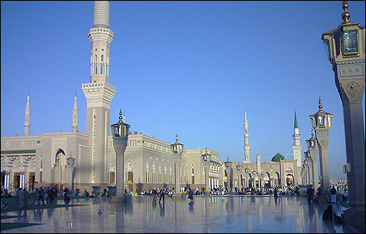

Visiting Madinah, the city of the Prophet (S), has no relation or connection with Hajj rituals as some people may believe. It is a separate thing that a person can do at any time during the year. Visiting the Prophet's Masjid is a recommended Sunnah. The Prophet (S) said.
Things to do:
- Pray two Rak'aas at the Rawdah as-Sharifah if possible once you enter the mosque. Otherwise in any place
close to it.
- Follow all the etiquette of entering and behaving in the mosques.
- Go near the Prophet's grave and say,
"As-SalaamualaykayaaRassul-Allah! As-SalaamualaykayaaNabiya-Allah! As-SalamualaykaYaakheeratakhalqil-Allah! Ash-Hadu an-laailaaha ill-Allah wa-ash-haduannaka 'abduhuwa-Rassuluh!Qadballaghtaar-Rissaala, wa-addaytal-Amaana, wanasahtal-Ummata, wa-Jaahadtafil-Lahihaqqajihaadihi! Sall-Allahu 'alayakawa 'alaaAalikawa-Azwaajikawa-Sallamataslimankathiran!"
Ziyarah in Madinah on 16 Zillhajj (Inshallah) After Fajj Pray
18Zillhajj Back to Japan.

Hajj AndUmrah Agent in Japan
Mian International

Shinagawa-Ku, Minami-Oi 6-16-12 (202) Tokyo.Japan.www.miantravel.com
Tel:03-3768-0898 Fax:03-3768-0977 Mian Phone in Saudi:0557231561
Ｗｒｉｔｅ ｂｙMianAbrar

